Name ____________________________

Math 8: Real-Life Slope, Part 1

Directions: Fill in the blanks below as you watch the video.

Let’s Review:

- Slope = rise/run
- Slope also means “rate of change”
- A rate is a ratio that compares 2 different units (like “price per pound” and “miles per hour”)
- In a table, the x-values go in the left column and the y-values go in the right column
- Slope may be calculated using any set of ordered pairs from a table or a graph

Wacky Weather

Date (x) Temp (y)  Rise =  Run | 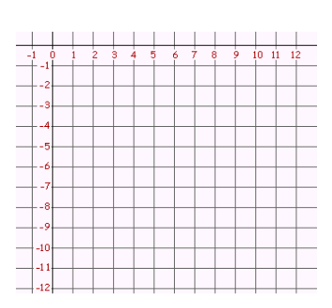
What is the rate of change? ________ / ________

Coco’s Carwash
Rise =  Run  What is the rate Coco charges per carwash?  __________ / __________ | 