**Name ____________________________**

**Math 8: Determining Slope from Graphs**

*Directions: Fill in the blanks below as you watch the video.*

**Let’s Review: Four Types of Slope**

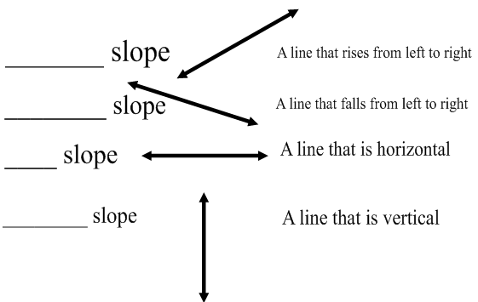

**Example A: Find the slope of this line.**

|  |  |
| --- | --- |
|  | 1) Find two points.  2) Find the rise.  3) Find the run.  4) Write the ratio in simplest form. |

**Example B: Find the slope of this line.**

|  |  |
| --- | --- |
|  | 1) Find two points.  2) Find the rise.  3) Find the run.  4) Write the ratio in simplest form. |

**Example C – You Try!: Find the slope of this line.**

|  |  |
| --- | --- |
|  | 1) Find two points.  2) Find the rise.  3) Find the run.  4) Write the ratio in simplest form. |

|  |  |
| --- | --- |
|  |  |

|  |  |
| --- | --- |
|  |  |

|  |  |
| --- | --- |
|  |  |

Example D:

Find another point on the line that goes through (4, 2) and has a slope of -3

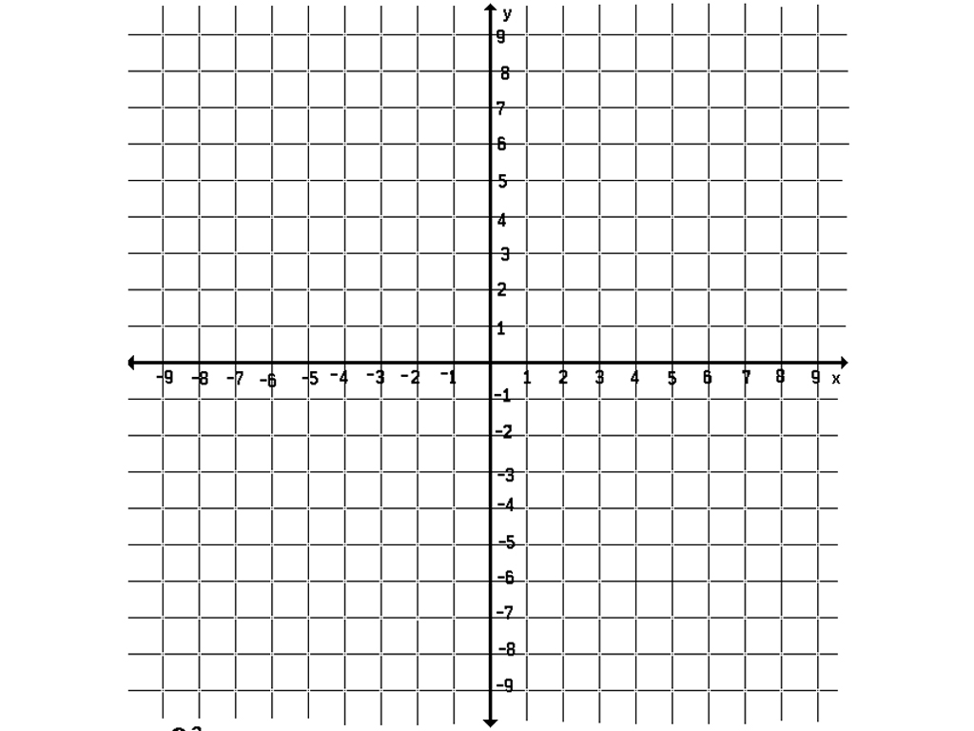

Example E- You Try!

Find another point on the line that goes through (-5, 1) and has a slope of ¼

