Name ____________________________

Math 8: Zero and Negative Exponents
Directions: Fill in the blanks below as you watch the video.
Let’s Reivew!
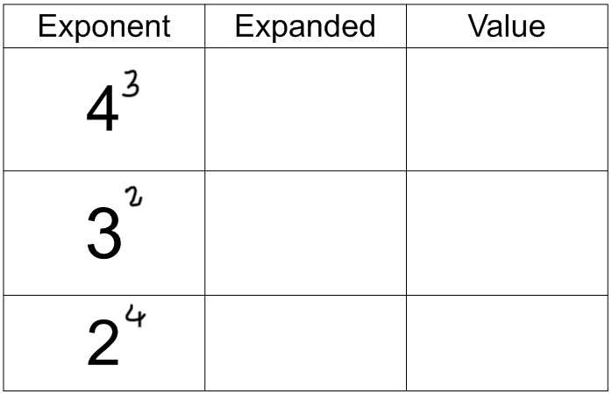
Let’s Investigate!
Exponent | Value

Rule: Zero Exponent
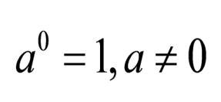
Rule: Negative Exponent
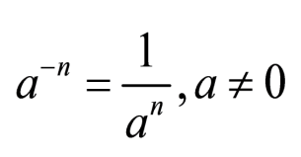
In other words ... a negative exponent always wants to _______! If it's on the top, it wants to go down to the __________. If it's on the bottom, it wants to move up to the ______.

Simplify. (Rewrite without negative exponents.)
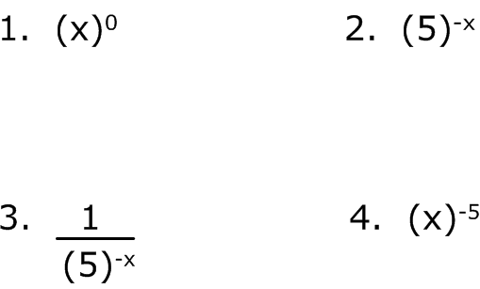

You Try! Simplify.
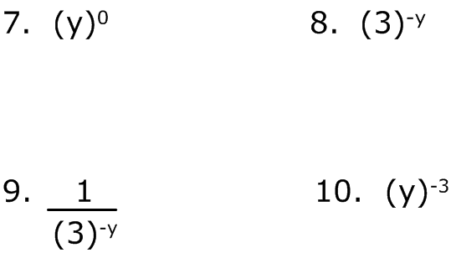

Simplify.
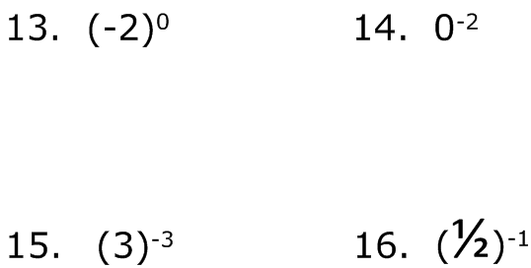

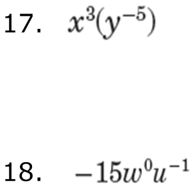

You Try! Simplify.
