Name ____________________________

Math 8: Multiplying with Exponents
Directions: Fill in the blanks below as you watch the video.
Write in expanded notation:

Now write back in exponential notation:

Product of Powers Property
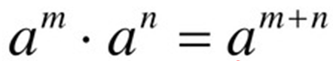
Simplify.
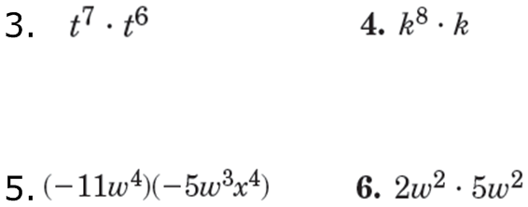

You Try! Simplify.
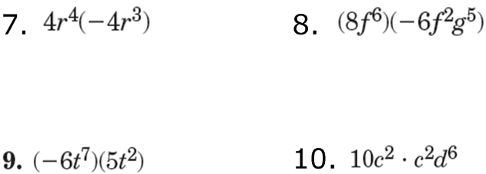

Simplify.

You Try! Simplify.

