Pythagorean Theorem & 3-D Figures Notes Name_________________

1. Find the length of the longest rod that could fit in the figures below.

72 cm
33 cm
56 cm

2. Find the height of the pyramid if the lengths of the sides of the triangles are 29cm, 29cm, and 40cm.

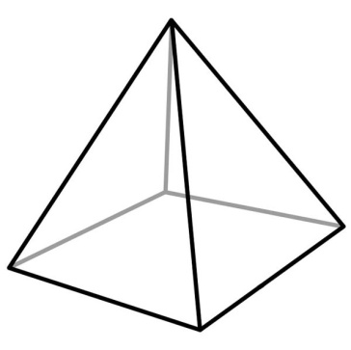

Pause the video and try the problems on the back on your own!
Then press play and check your answers with a color pen.

1. Find the length of the longest rod that could fit in the figures below.

12 cm
3 cm
4 cm

2. Find the height of the pyramid if the lengths of the sides of the triangles are 13cm, 13cm, and 10 cm.

