**EOC Review: Systems** Name: ___________________________

Math 1 Homework Date: _______________ Block: _____

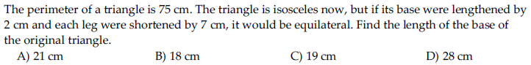



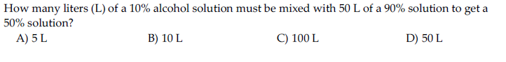



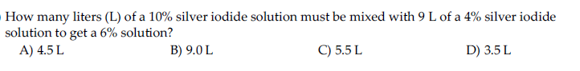



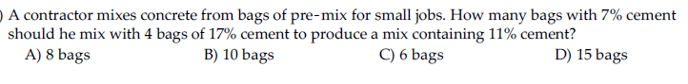



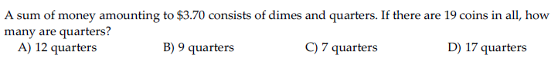







1. Graph

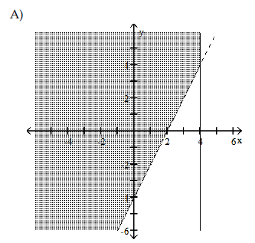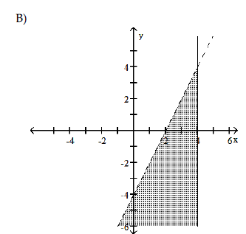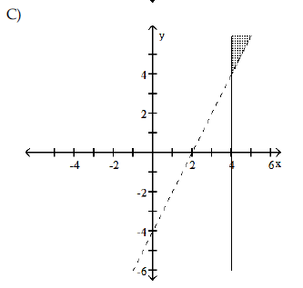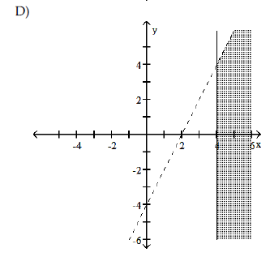



1. Graph

