EOC Questions - Equations and Linear Functions Name: __________________________

**1.**  If 8*x* = -4(*x* + 3) then x equals:

[A] -1

[B] 1

[C] ¾

[D] ¼

**2.**  Solve for *x*:  *9x2* - *c = d*

[A]

[B]

[C]

[D] $x= \sqrt{9cd}$

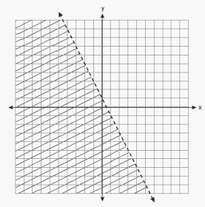**3.** Which inequality is represented by the graph at the right?

[A]  *http://regentsprep.org/REgents/math/ALGEBRA/MultipleChoiceReview/Equati2.gif*

[B] http://regentsprep.org/REgents/math/ALGEBRA/MultipleChoiceReview/Equati1.gif

[C]  *http://regentsprep.org/REgents/math/ALGEBRA/MultipleChoiceReview/Equati4.gif*

[D] http://regentsprep.org/REgents/math/ALGEBRA/MultipleChoiceReview/Equati3.gif

**4.**  Jared can run 520 yards in one minute. How fast does he run in feet per second?

[A] 12 [B] 26 [C] 1560 [D] 16

**5.**  There are three consecutive integers such that the sum of the two smallest integers is 17 less than three times the largest. What is the smallest integer?

[A] 5 [B] 7 [C] 12 [D] 6

**6.** Which expression is equivalent to: ${(16x^{-6}y^{4}z^{8})}^{-\frac{1}{4}}$

[A] $16x^{\frac{3}{2 }}yz^{2}$ [B] $2x^{2}yz^{2}$ [C] $\frac{x^{\frac{3}{2}}}{2yz^{2}}$ [D] $\frac{x^{\frac{3}{2}}}{16yz^{2}}$

**7.** Which graph below displays the equation 3x – 4y = 28

[A] 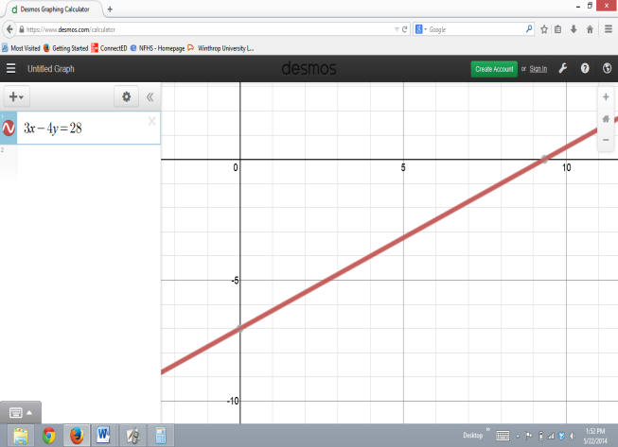 [B] 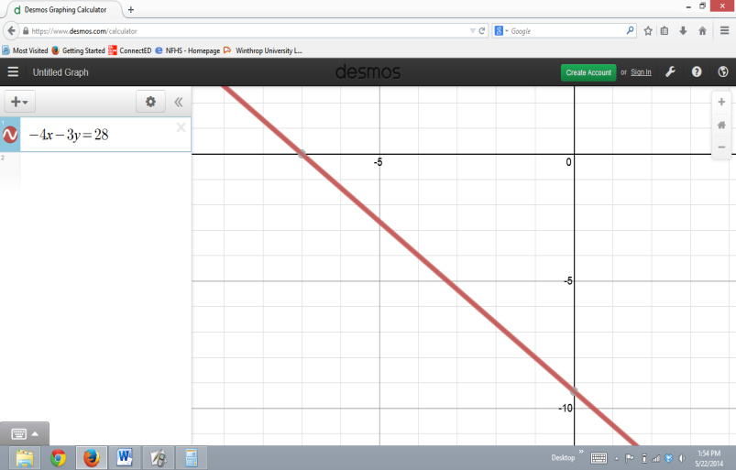 [C] 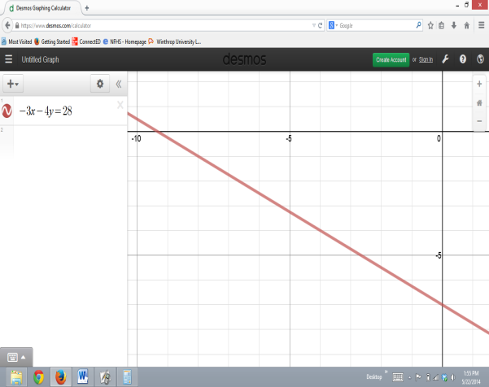

**8.** Compare the slope of f(x) = -2x + 3 and the slope of the chart of g(x) below:

|  |  |  |  |  |
| --- | --- | --- | --- | --- |
| x | 2 | 4 | 6 | 8 |
| g(x) | -8 | -2 | 4 | 10 |

What is the positive difference between the slopes of f(x) and g(x)?

[A] 1 [B] 5 [C] 8 [D] 17

**9.** Gregory teaches martial arts. He charges a one-time processing fee of $5.00 and the cost of the classes is shown below. Let x represent the number of classes and y represent the cost of classes.

|  |  |  |  |  |
| --- | --- | --- | --- | --- |
| Number of Classes, *x* | 1 | 2 | 3 | 4 |
| Cost of Classes(not including processing fee), y | $15.00 | $27.00 | $39.00 | $51.00 |

Based on this information, what will it cost to take 10 classes?

[A] $123 [B] $128 [C] $118 [D] $153

**10.** Jerami is going to deposit an equal amount of money into a checking account each month until he has saved $2,000. The amount of money, y, in the account after x months can be modeled by the equation y = 35x + 250.

What does the slope of the graph of the equation represent?

[A] The amount of money deposited monthly

[B] The amount of money originally in the account

[C] The number of months it would take to earn $250

[D] The number of months it would take to reach $2,000

**11.** Find the range of the function represented in the graph.



[A] The range consists of values from -5 to 3.

[B] The range consists of values from -4 to 6.

[C] The range consists of values from -5 to 6.

[D] The range consists of values from -4 to 3.

**12.** Which equation represents the line passing through the points (3, 2) and (–9, 6)?

[A] *x* – 3*y* = 9

[B] *x* + 3*y* = 9

[C] 3*x* – *y* = -9

[D] 3*x* + *y* = 9

**13.** Which of the following represents the linear equation 3(x+2)= 12 – 2*y* in standard form?

[A] y = -3/2x + 3

[B] y = 3/2x - 3

[C] 3*x* – 2*y* = 10

[D] 3*x* + 2*y* = 6